

D365 F&O: Vendor Invoices (NZ)
Procedure Guide

Contents

About this guide 3
Part 1: What do I need to know? (Vendor Invoices) 4
High-level process 4
Roles and responsibilities 6
Key concepts 7
Part 2: How do I do it? (Vendor Invoices) 9
1. Create a Vendor Invoice 9
1.1 Search for an Existing Purchase Order 10
1.2 Create a Vendor Invoice from a Purchase Order 12
1.3 Create a Manual Vendor Invoice 14
1.4 Add an Attachment to a Vendor Invoice 15
2. Submit a Vendor Invoice to the Workflow 16
3. Post a Vendor Invoice 18
4. Confirm a Purchase Order 20
Part 3: Reports (Vendor Invoices) 21
Additional Resources 24

ID | Date | Author/s | BPO | Description of change
0.2 | January 2025 | Michael Thurlow | Ghada Boulos | Version 0.2 (NZ), released 30 January 2025, in the earlier PG format.
1.0 | November 2026 | Daniel Moreira | Ghada Boulos | Working draft (D-057): converted from version 0.2 to the PG master template. Topics grouped into four, one action per row, the standard navigation pattern, and each report in its own table. Not validated or approved.

About this guide

WHAT is this guide used for?
This guide includes context and step-by-step ‘how to’s’ about the D365 F&O: Vendor Invoices process. It has been developed as the primary on-the-job reference to support WTG team members responsible for completing D365 F&O system tasks.

HOW to navigate this guide?
This guide is made up of Parts and Topics. A Part represents a collection of related topics (e.g., a set of related procedures). A Topic represents a specific item of information related to the Part. Each Part and Topic can be accessed from the Table of Contents.

Part 1: What do I need to know?
This part provides an overview of the end-to-end business process covered in this document. It outlines the purpose, scope, and context of the process within the broader functional stream, and introduces key roles, systems, and activities involved.

Part 2: How do I do it?
This part contains detailed steps on completing specific tasks in the D365 system. The instructions used in this guided approach are split into two main (2) sections:
- Action: section one (1) of the information table; one individual action per row, beginning with an italicized verb.
- Description: section two (2) of the information table; location, exact values, context, expected results and relevant notes.

Note: Part 1 and Part 2 will be consistent across all D365 Procedure Guides (PGs). PGs may include additional Parts covering major topics related to the specific module / PG.

Hyperlinks
Hyperlinks are used throughout this document. Click on a hyperlink to directly navigate to another topic in this guide, or to an external resource.

Key
The table below defines what colors are used to highlight specific sections in this document:
Color | Definition
 | Highlight an off-system action
 | Highlights the start / end of a step.
 | Highlights the end of the process.

Part 1: What do I need to know? (Vendor Invoices)

High-level process

Part Description
Vendor Invoices is part of the Purchase-to-Pay (P2P) stream. This guide sets out the D365 F&O procedures that the Accounts Payable team uses to create, submit and post vendor invoices for New Zealand.

Vendors send their invoices by email to apanz@wisetechglobal.com. For each invoice, the Accounts Payable Specialist searches D365 F&O for the purchase order that the invoice relates to. If an existing purchase order is located, the vendor invoice is created from the purchase order and matched against it. If no purchase order can be located, a manual vendor invoice is created. The invoice file received by email is then attached to the invoice in D365 F&O.

Every vendor invoice is submitted to the workflow, regardless of its amount; the workflow notifies Treasury of any amount over $100,000. When the workflow status is Completed, the invoice is posted. If the invoice is still displayed on the Pending vendor invoices page after posting, its purchase order is confirmed.

At a high level, the Vendor Invoices process follows these stages:
- Create a Vendor Invoice: search for the purchase order, create the invoice from it or manually, and attach the invoice file.
- Submit a Vendor Invoice to the Workflow: submit every invoice, and check that its workflow status is Completed.
- Post a Vendor Invoice: post the invoice from the Pending vendor invoices page.
- Confirm a Purchase Order: confirm the purchase order when a posted invoice is still displayed on the Pending vendor invoices page.

This guide covers the new D365 F&O activities only; existing business-as-usual (BAU) activities are not included. The other process areas of the P2P stream are Vendor Onboarding and Maintenance (Accounts Payable), Purchase Requisitions (Business User / Requestor) and Vendor Payments (Accounts Payable).

Initiation
- A vendor sends an invoice to apanz@wisetechglobal.com.

Stream
Stream | Process Area | Key Roles
Purchase-to-Pay (P2P) | Vendor Invoices | - Accounts Payable Specialist

Process
The high-level Vendor Invoices process is as follows:
# | Action | Who | When | Where
0 | Send a vendor invoice to apanz@wisetechglobal.com | Vendor | Ad hoc | Email
1 | Create a Vendor Invoice | Accounts Payable Specialist | When a vendor invoice is received | D365 F&O
2 | Submit a Vendor Invoice to the Workflow | Accounts Payable Specialist | When a vendor invoice is created in D365 F&O | D365 F&O
3 | Post a Vendor Invoice | Accounts Payable Specialist | When the workflow status is Completed | D365 F&O
4 | Confirm a Purchase Order | Accounts Payable Specialist | When a posted invoice is still displayed on the Pending vendor invoices page | D365 F&O

Roles and responsibilities

Overview
The Accounts Payable Specialist creates vendor invoices, attaches the invoice files, submits the invoices to the workflow and posts them, and confirms a purchase order when an invoice stays pending. Vendors send their invoices to the Accounts Payable mailbox, and the workflow notifies Treasury of any amount over $100,000.
Tasks / Business Roles | Accounts Payable Specialist
1 Create a Vendor Invoice | R
1.1 Search for an Existing Purchase Order | R
1.2 Create a Vendor Invoice from a Purchase Order | R
1.3 Create a Manual Vendor Invoice | R
1.4 Add an Attachment to a Vendor Invoice | R
2 Submit a Vendor Invoice to the Workflow | R
3 Post a Vendor Invoice | R
4 Confirm a Purchase Order | R
*R = Responsible
Note: The business roles shown above are responsible for completing D365 F&O tasks on a day-to-day basis; however, other business roles may also have access to the same functionality to complete these tasks when required.

Key concepts

Overview
Before you start, you need to know how a vendor invoice is linked to a purchase order, which type of invoice to create, what the match status shows, and what the workflow does.

Purchase Orders and Requisitions
Term | Description
Purchase order number | The vendor invoice provides the purchase order number. Use it to find the purchase order in D365 F&O.
Purchase requisition | The Accounts Payable Specialist finds the purchase order from the All purchase requisitions page. The Purchase order field on the Purchase requisition lines shows the purchase order number.  The purchase requisition status should be Closed.

Vendor Invoice Types
Invoice type | When it is used
Vendor invoice from a purchase order | A physical invoice is received from a vendor and an existing purchase order is located in D365 F&O: a purchase order number is shown in the Purchase order field. See 1.2 Create a Vendor Invoice from a Purchase Order.
Manual vendor invoice | A physical invoice is received from a vendor and an existing purchase order cannot be located in D365 F&O: the Purchase order field is blank. See 1.3 Create a Manual Vendor Invoice.

Match Status
Status | What to do
Not performed | Shown after the invoice details are entered, before the match status is updated.
Passed | Save the invoice and continue.
Failed | Open the Matching details to find the reason for the failure, and correct the invoice before you continue.

Vendor Invoice Workflow
Rule | Description
Submit every invoice | All vendor invoices must be submitted to the workflow, regardless of the amount.
Treasury notification | The workflow notifies Treasury of any amount over $100,000.
Completed status | The workflow status must be Completed before the invoice is posted. Check it in Workflow > Workflow history.

Pending Vendor Invoices
Term | Description
Pending vendor invoices page | Lists the existing pending vendor invoices. A posted invoice is no longer displayed on this page.
Invoice still displayed after posting | Confirm its purchase order: see 4 Confirm a Purchase Order.

Part 2: How do I do it? (Vendor Invoices)

Create a Vendor Invoice

Description
A vendor invoice is created in D365 F&O for each invoice that a vendor sends to apanz@wisetechglobal.com. The Accounts Payable Specialist first searches for the purchase order that the invoice relates to. If an existing purchase order is located, the invoice is created from the purchase order and its match status is updated; if not, a manual vendor invoice is created. In both cases, the invoice file received by email is attached to the invoice, which is then ready to submit to the workflow.

Responsibility
- Accounts Payable Specialist: creates the vendor invoice and attaches the invoice file.

Initiation
- A vendor invoice is received in the apanz@wisetechglobal.com mailbox.

Topic Overview
This topic includes these steps:
Step | Description
1.1 Search for an Existing Purchase Order | Find the purchase order number on the purchase requisition, to decide which type of invoice to create.
1.2 Create a Vendor Invoice from a Purchase Order | Used when an existing purchase order is located. Output: a saved vendor invoice with an updated match status.
1.3 Create a Manual Vendor Invoice | Used when no purchase order can be located. Output: a saved manual vendor invoice.
1.4 Add an Attachment to a Vendor Invoice | Attach the invoice file received by email. Output: a vendor invoice ready to submit to the workflow.

Search for an Existing Purchase Order

Procedure
Complete these steps to search for an existing purchase order:
Action | Description
PROCESS START | Pre-requisites:  - The vendor invoice received by email, with the purchase order number it provides.  Responsibility:  - Accounts Payable Specialist
- Check the Entity. | Confirm you are signed into the correct Legal Entity (top-right).
- Click Modules. | From the left-hand Navigation Pane, click Modules.
- Navigate to the All purchase requisitions page. | From the Navigation Pane, select:  - Procurement and sourcing >  - Purchase requisitions >  - All purchase requisitions  The All purchase requisitions page opens and displays a list of existing purchase requisitions.
- Select the Purchase Requisition. | Click the purchase requisition for the vendor invoice.  The purchase requisition status should be Closed.  The Purchase requisitions page opens.
- Check the Purchase order column. | Under Purchase requisition lines, check that the Purchase order column is displayed.  If it is displayed, go to step 11. If it is not displayed, continue with step 6.
- Right-click the line header. | Right-click anywhere on the line header of Purchase requisition lines.
- Click Insert columns. | Click Insert columns.
- Select Purchase order. | In the list of fields, select Purchase order.
- Click Update. | Click Update to add the Purchase order field to the line.
- Move the Purchase order column. | Optional: click and drag the Purchase order field to the location you want.
- Locate the Purchase Order number. | Under Purchase requisition lines, locate the purchase order number in the Purchase order field.  Tip: Use the purchase order number provided on the vendor invoice.  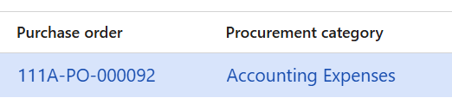
STEP COMPLETE | - If a purchase order number is shown in the Purchase order field, an existing purchase order is located. Continue to 1.2 Create a Vendor Invoice from a Purchase Order.  - If the Purchase order field is blank, no purchase order can be located. Continue to 1.3 Create a Manual Vendor Invoice.

Create a Vendor Invoice from a Purchase Order

Procedure
Complete these steps to create a vendor invoice from a purchase order:
Action | Description
PROCESS START | Pre-requisites:  - The purchase order number is shown on the purchase requisition lines (1.1 Search for an Existing Purchase Order).  - The vendor invoice, with its invoice number, description and date.  Responsibility:  - Accounts Payable Specialist
- Click the Purchase Order number. | Under Purchase requisition lines, click the purchase order number in the Purchase order field.  The Purchase order page opens.
- Click Invoice > Generate > Invoice. | On the Main Toolbar, click Invoice > Generate > Invoice.  The invoice is generated and the Vendor invoice page opens.
- Select Default from. | On the Main Toolbar, set Default from to Ordered quantity.  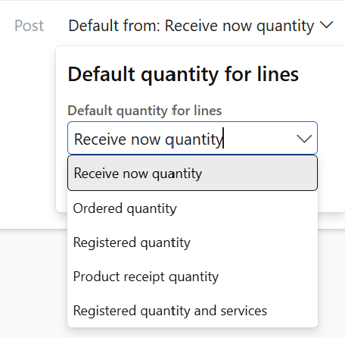
- Click OK. | The default quantity is updated according to the selection.
- Enter Number. | Enter the invoice number from the vendor's invoice.
- Enter Invoice description. | Enter the invoice description from the vendor's invoice.
- Enter Invoice date. | Enter the invoice date from the vendor's invoice.  Note: The Match status shows Not performed.  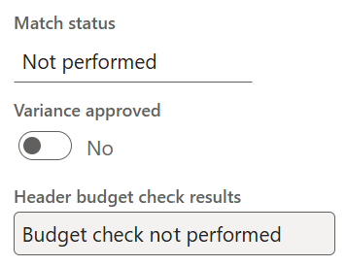
- Click Update match status. | On the Main Toolbar, click Update match status. The Match status is updated.  If the Match status is Passed, go to step 11.  If the Match status is Failed, go to step 9.
- Click Review > Matching > Matching details. | On the Main Toolbar, click Review > Matching > Matching details.  Note: If Review is not visible on the Main Toolbar, click the ellipsis (...).  The Invoice matching details page opens.  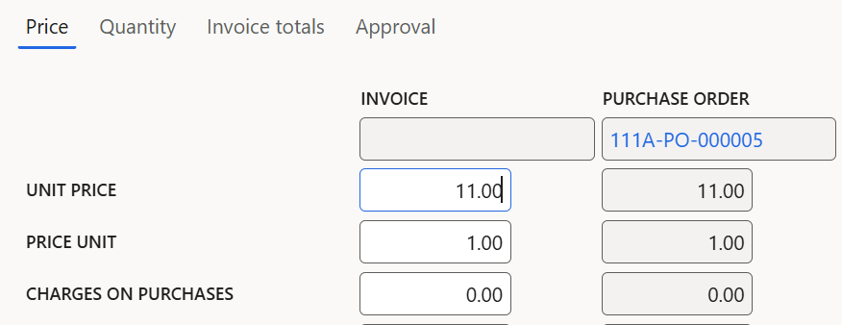
- Review the Matching Details. | Review the available details to find the reason for the failure, and correct the invoice as required before you continue.
- Click Save. | On the Main Toolbar, click Save. The changes are saved.
- Click Back. | On the Main Toolbar, click Back (arrow). You return to the Vendor invoice page.
STEP COMPLETE | - The vendor invoice is created from the purchase order and saved.  - Continue to 1.4 Add an Attachment to a Vendor Invoice.

Create a Manual Vendor Invoice

Procedure
Complete these steps to create a manual vendor invoice:
Action | Description
PROCESS START | Pre-requisites:  - No purchase order can be located: the Purchase order field is blank (1.1 Search for an Existing Purchase Order).  - The vendor invoice, with its vendor, invoice number, description, date and line details.  Responsibility:  - Accounts Payable Specialist
- Check the Entity. | Confirm you are signed into the correct Legal Entity (top-right).
- Click Modules. | From the left-hand Navigation Pane, click Modules.
- Navigate to the Pending vendor invoices page. | From the Navigation Pane, select:  - Accounts payable >  - Invoices >  - Pending vendor invoices  The Pending vendor invoices page opens and displays a list of existing pending vendor invoices.
- Click New. | On the Main Toolbar, click New. The Vendor invoice page opens.
- Select Invoice account. | Under the Vendor invoice header section, select the vendor's invoice account.
- Enter Number. | Enter the invoice number from the vendor's invoice.
- Enter Invoice description. | Enter the invoice description from the vendor's invoice.
- Enter Invoice date. | Enter the invoice date from the vendor's invoice.
- Click Add line. | Under Lines, click Add line.
- Select Procurement category. | Select the procurement category, for example PRIN > Printing and Stationery.
- Click OK. | Click OK to confirm the procurement category.
- Enter Quantity. | Enter the quantity, for example 10.
- Select Unit. | Select Each.
- Enter Unit price. | Enter the unit price, for example 10.
- Click Save. | On the Main Toolbar, click Save. The changes are saved.
STEP COMPLETE | - The manual vendor invoice is saved.  - Continue to 1.4 Add an Attachment to a Vendor Invoice.

Add an Attachment to a Vendor Invoice

Procedure
Complete these steps to add an attachment to a vendor invoice:
Action | Description
PROCESS START | Pre-requisites:  - The vendor invoice is saved and open on the Vendor invoice page (1.2 Create a Vendor Invoice from a Purchase Order or 1.3 Create a Manual Vendor Invoice).  - The vendor invoice file received by email.  Responsibility:  - Accounts Payable Specialist
- Click Attachments. | On the Main Toolbar, click Attachments. The Attachments for Vendor invoices page opens.
- Click New > File. | On the Main Toolbar, click New > File. The Upload document pane opens.
- Click Browse. | In the Upload document pane, click Browse.
- Select the Vendor Invoice file. | Locate and select the vendor invoice file.  The vendor invoice file is uploaded and displayed in the left-hand pane.
- Enter Description. | Optional: update the Description as required.
- Click Save. | On the Main Toolbar, click Save. The changes are saved.
- Click Back. | On the Main Toolbar, click Back (arrow). You return to the Vendor invoice page.
STEP COMPLETE | - The vendor invoice file is attached to the vendor invoice.  - Continue to 2 Submit a Vendor Invoice to the Workflow.

Submit a Vendor Invoice to the Workflow

Description
Every vendor invoice is submitted to the workflow, regardless of its amount. The workflow notifies Treasury of any amount over $100,000. The workflow status must be Completed before the invoice is posted.

Responsibility
- Accounts Payable Specialist: submits the vendor invoice to the workflow and checks its status.

Initiation
- A vendor invoice is created in D365 F&O and its invoice file is attached (1.4 Add an Attachment to a Vendor Invoice).

Procedure
Complete these steps to submit a vendor invoice to the workflow:
Action | Description
PROCESS START | Pre-requisites:  - The vendor invoice is open on the Vendor invoice page, with its invoice file attached (1.4 Add an Attachment to a Vendor Invoice).  Responsibility:  - Accounts Payable Specialist
- Click Workflow. | On the Main Toolbar, click Workflow. The Vendor invoice workflow pop-up appears.
- Click Submit. | Click Submit. The Submit pane opens.
- Enter Comment. | Optional: enter a comment, if required.
- Click Submit. | In the Submit pane, click Submit. The vendor invoice is submitted to the workflow.
- Click Workflow > Workflow history. | On the Main Toolbar, click Workflow > Workflow history to check the status.  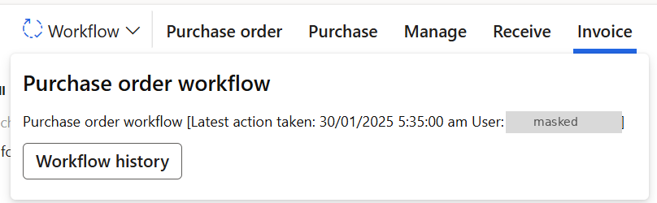
- Confirm the Status is Completed. | The workflow status must be Completed before you continue.  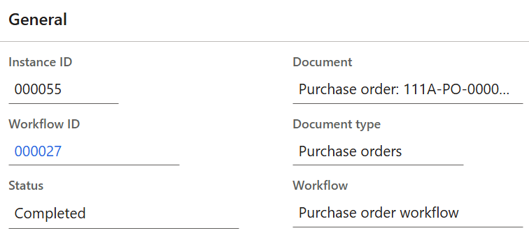
STEP COMPLETE | - The vendor invoice is submitted to the workflow, and its workflow status is Completed.  - Continue to 3 Post a Vendor Invoice.

Post a Vendor Invoice

Description
A vendor invoice is posted once it has been submitted to the workflow and its workflow status is Completed. After posting, the invoice is no longer displayed on the Pending vendor invoices page. If it is still displayed, its purchase order must be confirmed: see 4 Confirm a Purchase Order.

Responsibility
- Accounts Payable Specialist: posts the vendor invoice.

Initiation
- The workflow status of a vendor invoice is Completed (2 Submit a Vendor Invoice to the Workflow).

Procedure
Complete these steps to post a vendor invoice:
Action | Description
PROCESS START | Pre-requisites:  - The workflow status of the vendor invoice is Completed (2 Submit a Vendor Invoice to the Workflow).  Responsibility:  - Accounts Payable Specialist
- Check the Entity. | Confirm you are signed into the correct Legal Entity (top-right).
- Click Modules. | From the left-hand Navigation Pane, click Modules.
- Navigate to the Pending vendor invoices page. | From the Navigation Pane, select:  - Accounts payable >  - Invoices >  - Pending vendor invoices  The Pending vendor invoices page opens and displays a list of existing pending vendor invoices.
- Select the Vendor Invoice. | Click the vendor invoice. The Invoice page opens.
- Click Post. | On the Main Toolbar, click Post.  The pop-up message Processing operation – Purchase invoice appears. When it is complete, the system message Operation completed is displayed and the invoice is posted.
- Check the Pending vendor invoices page. | Check whether the invoice is still displayed on the Pending vendor invoices page.  If it is no longer displayed, the invoice is posted.  Note: The invoice can be viewed under Accounts payable > Purchase orders > All purchase orders, then, on the Main Toolbar, click Invoice > Generate > Invoice.  If it is still displayed, go to 4 Confirm a Purchase Order.
PROCESS COMPLETE | Outcomes:  - The vendor invoice is posted and is no longer displayed on the Pending vendor invoices page.

Confirm a Purchase Order

Description
A purchase order is confirmed to enable a vendor invoice to be processed. Confirm the purchase order when a vendor invoice is still displayed on the Pending vendor invoices page after it is posted (3 Post a Vendor Invoice).

Responsibility
- Accounts Payable Specialist: confirms the purchase order.

Initiation
- A posted vendor invoice is still displayed on the Pending vendor invoices page.

Procedure
Complete these steps to confirm a purchase order:
Action | Description
PROCESS START | Pre-requisites:  - A posted vendor invoice is still displayed on the Pending vendor invoices page (3 Post a Vendor Invoice).  - The purchase order number of that invoice.  Responsibility:  - Accounts Payable Specialist
- Check the Entity. | Confirm you are signed into the correct Legal Entity (top-right).
- Click Modules. | From the left-hand Navigation Pane, click Modules.
- Navigate to the All purchase orders page. | From the Navigation Pane, select:  - Procurement and sourcing >  - Purchase orders >  - All purchase orders  The All purchase orders page opens and displays a list of existing purchase orders.
- Select the Purchase Order. | Click the purchase order. The purchase order opens.
- Click Purchase > Actions > Confirm. | On the Main Toolbar, click Purchase > Actions > Confirm. The purchase order is confirmed.
PROCESS COMPLETE | Outcomes:  - The purchase order is confirmed, so that the vendor invoice can be processed.

Part 3: Reports (Vendor Invoices)

Overview
The following D365 F&O standard reports are available in the Accounts Payable module. They show vendor balances, invoices, transactions and purchase spending. For instructions to run a standard report, refer to the D365 F&O Reports: Run a Standard Report Quick Reference Card.

Vendor Ageing Report
Navigation | Description
- Accounts payable >  - Enquiries and reports >  - Vendor ageing report | The Vendor ageing report shows the balances that are due to vendors. Balances on the report are sorted either by date interval or by ageing period definition.

Purchase Orders Received but Not Invoiced
Navigation | Description
- Accounts payable >  - Purchase orders >  - Purchase orders received but not invoiced | This report displays the accrued purchases linked to purchase orders that have been received but not invoiced. It is displayed in a grid, where the transactions can be processed and exported to Microsoft Excel.

Vendor Base Data
Navigation | Description
- Accounts payable >  - Enquiries and reports >  - Vendor reports >  - Vendor base data | This report can be printed for the periodic tax review. It includes the Tax Group, WHT Tax Group, Address (Location) and other relevant data fields.  Alternatively, the vendor master form can be personalized to include the fields required for the periodic tax review, and then exported to Excel.

Vendor/Item Statistics
Navigation | Description
- Procurement and sourcing >  - Enquiries and reports >  - Vendor statistics >  - Vendor/Item statistics | The Vendor/Item statistics report displays a summary of the products purchased from each vendor during the specified date range. A second date range can be added for comparison.

Vendor Transactions Report
Navigation | Description
- Accounts payable >  - Enquiries and reports >  - Vendor transactions report | Use this report to print the vendor voucher transactions, that is, the records posted to the Accounts Payable subledger.

Vendor Tax Invoice Journal Report
Navigation | Description
- Accounts payable >  - Enquiries and reports >  - Invoice >  - Vendor tax invoice journal report | Use this report to print a list of vendor invoices.

Vendor Posted Payment Journal Report
Navigation | Description
- Accounts payable >  - Enquiries and reports >  - Payment >  - Vendor posted payment journal report | The Vendor posted payment journal report shows the details of posted vendor accounts and vendor payments for individual vendors. It displays the payment amount, original transaction amount, discount amount and write-off amount, with the original transaction currency and the payment currency.  The report also displays the type of journal posted, the vendor account, the payment reference, and whether any journal vouchers are canceled.

Purchase and Spend Analysis
Navigation | Description
- Procurement and sourcing >  - Enquiries and reports >  - Purchase performance analysis >  - Purchase and spend analysis | The Purchase spend analysis Power BI content helps purchasing managers, and managers who are responsible for budgets, keep track of purchase spending. Managers can analyze purchase spending by:  - Year-to-date purchases (by vendor group and individual vendor, procurement category and individual product, and vendor location).  - Year-over-year purchase change (by vendor group and procurement category).

Payment Times Reporting Scheme (PTRS)
Navigation | Description
- Accounts payable >  - Periodic tasks >  - Statistics on invoices, then select Payment times report | The Australian government established the PTRS to help improve payment times for Australian small businesses. Under the scheme, large businesses and government enterprises must report their small business payment terms and times every six months of an income year. Legal entities must also include payment information about the goods and services they procured from small business suppliers under a trade credit arrangement.

Account Statement
Navigation | Description
- Accounts payable >  - Enquiries and reports >  - Vendor reports >  - Account statement | Use this report to print and view internal account statements for each vendor account. Each statement includes basic vendor information, such as the vendor's name, address and terms of payment, and transaction information, such as the transaction date, voucher number, invoice number, due date and amounts.

Vendor to Ledger Reconciliation
Navigation | Description
- Accounts payable >  - Enquiries and reports >  - Vendor reports >  - Vendor to ledger reconciliation | Use this report to reconcile the balances of vendor and ledger accounts. The sum of all vendor transactions is compared with the sum of all the ledger transactions posted to the related vendor summary accounts. You can specify intervals for dates, vouchers and vendor accounts, according to the vendor posting profile.

Vendor Balance List
Navigation | Description
- Accounts payable >  - Enquiries and reports >  - Vendor reports >  - Vendor balance list | Use this report to show, side by side, how vendor balances have changed during a defined subperiod, such as last month, and a defined period, such as the current year. The report shows credit totals, which often represent the amounts that were invoiced, and debit totals, which are usually the amounts that were paid.

Additional Resources

User Support
- For any D365 issues during go-live and early adoption, log requests through the D365 issue form on the Atlas D365 User Support Hub. This is the fastest way to get help.

Self-Service Resources
- AVA - Atlas Virtual Assistant: Your AI assistant for navigating the Procedure Guides and quickly finding the right steps for any D365 task.
- Procedure Guides: Step-by-step instructions for core D365 processes.
- Atlas Training Hub: Access to training recordings, guides, quick reference material, and learning artifacts.

